

web development (wede 5020)
Karabo Jjaone
ST10485247
GROUP 1

Table of Contents
1. Organisation Overview: 2
2. Website Goals and Objectives: 3
4. Proposed Website Features and Functionality: 4
5. Design and User Experience 5
6. Technical Requirements: 7
7. Timeline and Milestones: 0
8. Budget: 1
9. References 2

1. Organisation Overview:

Name: Hulela Projects

History of Organisation: Founded on a passion for innovation and a commitment to excellence, Hulela Projects has grown to be a trusted partner for businesses. Established in 2019, our team brings vast experience in SHEQ, Software Development, and Data Management.

Mission and Vision Statements:
Mission: Empower businesses by combining deep industrial expertise with futuristic innovation.
Vision: To be the leading partner in industrial innovation, transforming traditional processes through cutting-edge technology and strategic insight that drives sustainable growth.

Target audience:
- SHEQ Management
- Data Management



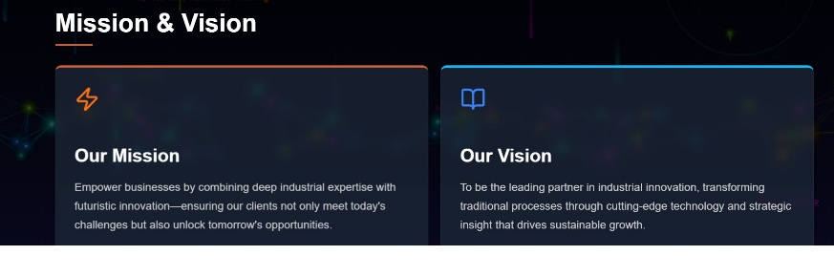
(Hulela Projects, 2019)

2. Website Goals and Objectives:

- Gaining Clients
A website helps in developing clients who would purchase regularly.
- Opportunity
A website can be effectively used for earning customer trust.

Business objective is to assist our clients in reducing the cost of running their business

Determine and present key performance indicators (KPIs) to measure success.

Customer (Satisfaction & Loyalty)
- Measures customer loyalty and likelihood to recommend.

Financial KPIs (Profitability & Growth)
- Percentage of revenue remaining after all expenses. (On Strategy, 2024)

4. Proposed Website Features and Functionality:

- Home: The headline on the homepage explains what the business does.
- Services: Informing customers of offerings of the business
- About Us: The about us page is an overview of the business.
- Stats: The stats page is for verifiable information.
- Contact Us: The contact us page is for contacting the business.
(Zoho, 2023)

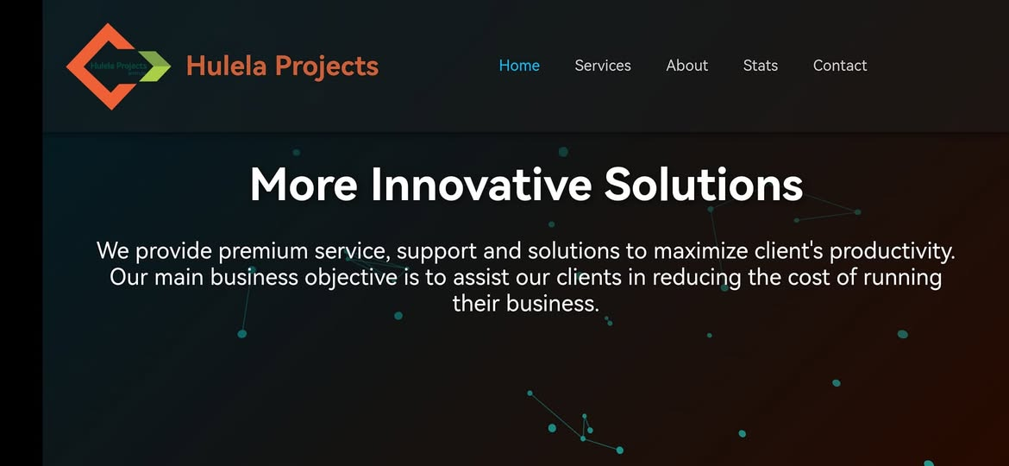 (Hulela Projects, 2019)

5. Design and User Experience

The website presents a modern, tech-driven corporate aesthetic

Colour Scheme:
Primary: Dark navy
Secondary: Teal
Accent 1: Orange
Accent 2: Green
Neutral: White

Typography:
Headings: Poppins
Body: Open Sans

Hierarchy:
H1: Large, bold

Layout and Design:
- Top Navigation Bar
- Hero Section (headline + description)
- Background visual effects (network dots/lines)

User Experience
Navigation:
- Home
- Services
- About
- Stats
- Contact

Layout
- Clear entry point
- Add scroll indicator or arrow

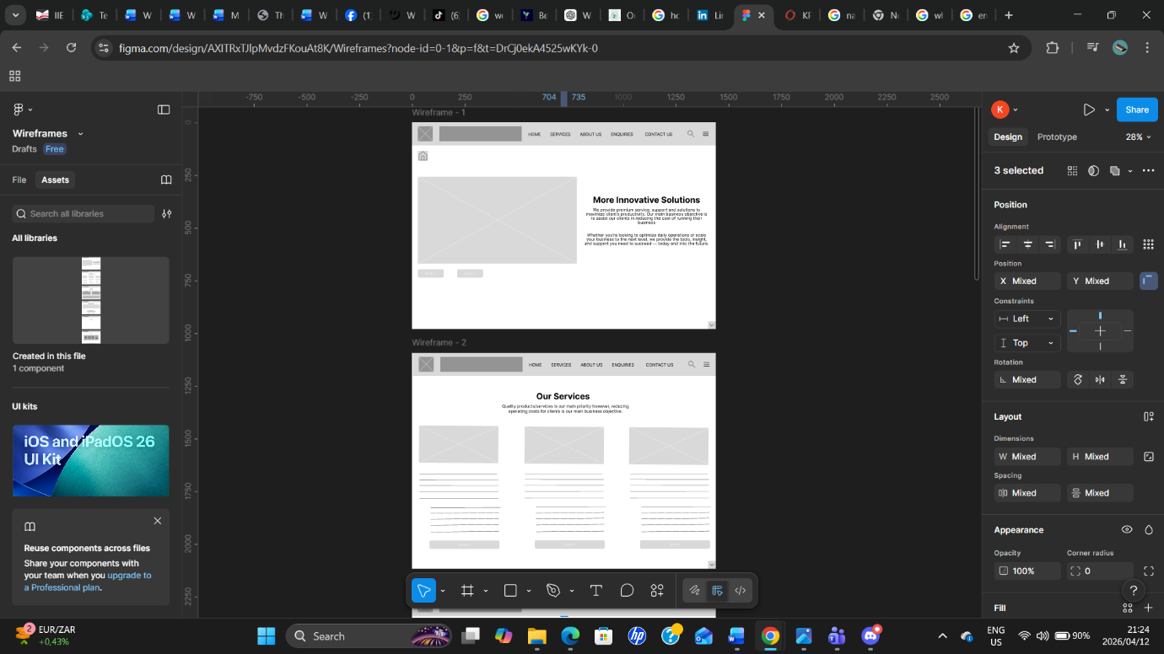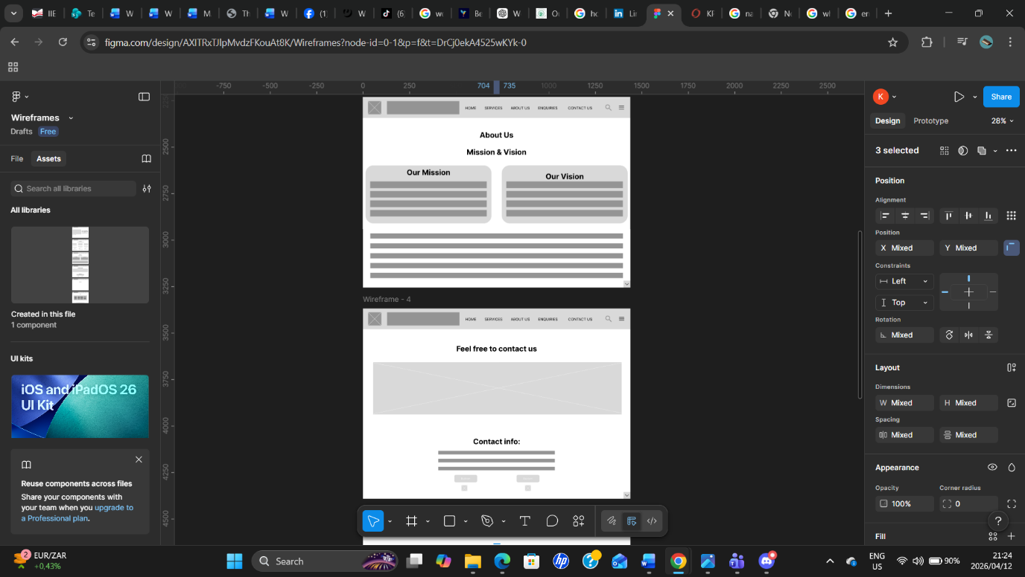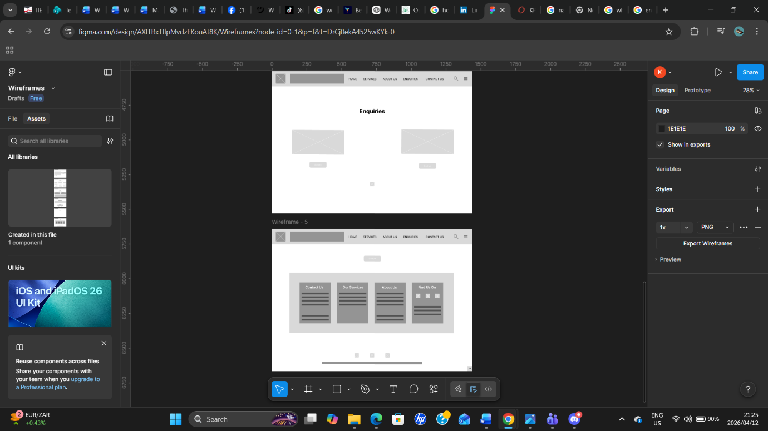

https://www.figma.com/design/AXITRxTJlpMvdzFKouAt8K/Proposal-1-Wireframes?t=UUZtpg2ZJvG24zD3-1

6. Technical Requirements:

Domain Name Requirements
- Registration: A unique address (.com) registered through a domain name

Hosting Requirements
- Shared Hosting: Affordable for small blogs or personal sites. (Host Africa, 2026)

Programming Languages
- HTML: Structures the content of the page.
- CSS: Adds styling.
- JavaScript: Adds interactivity. (Coventry Domains, 2019)

7. Timeline and Milestones:

  - PROJECT TIMELINE (APRIL)
• 1st–12th April: Research proposal submission.
• 13th–15th April: Reviews of proposals; ongoing communication with lecturer for feedback.
• 15th–16th April: Research and Content Gathering.
• 17th–18thApril: Create a HTML Structure
•18th-20th April: Organise files

8. Budget:

1. Development Budget (One-time Cost)
- Small Business/Corporate Site (5-10 Pages): R5000 – R12000. (Symaxx, 2026)

2. Hosting
- Domain Registration (.com): R100 – R300 per year.
- Hosting: R1,200 – R3,000 per year for shared, reliable hosting.

3. Maintenance
- Maintenance: R300 – R600 per month. (Owlmedia, 2026)

9. References
Conventry Domains, 2019. HTML, CSS and the Languages of the Web. [online] Available at: https://coventry.domains/learn/languages-of-the-web/ [Accessed 4 April 2026]

Host Africa, 2026. Web Hosting vs Domain Name: A Comprehensive Guide. [online] Available at: https://hostafrica.co.za/blog/domains/domain-basics/domain-vs-hosting/ [Accessed 4 April 2026]

Hulela Projects, 2019. Hulela Projects. [online] Available at: https://www.facebook.com/hulelaprojects/ [Accessed 4 April 2026]

On Strategy, 2024. KPIs Meaning + 27 Examples of Key Performance Indicators. [online] Available at: https://onstrategyhq.com/resources/27-examples-of-key-performance-indicators/ [Accessed 4 April 2026]

Owl Media, 2026. Website Price Ranges in South Africa for 2026: The Quick Answer. [online] Available at: https://owlmedia.co.za/how-much-does-a-website-cost-in-south-africa-2026-pricing-guide/ [Accessed 4 April 2026]

Zoho, 2023. Creating a website that engages: The key functionalities you need to include. [online] Available at: https://www.zoho.com/en-au/tech-talk/functionalities-of-a-website.html [Accessed 4 April 2026]

